**Name: Damien Robinson**

**Student Number: s5014219**

**Workshop Time: Thursday 2-4pm**

**Email: damien.robinson@griffithuni.edu.au**

Web Design 1621ICT

Semester 1, 2015

**Project Plan for Church of Gabe Newell Website**

**Project objectives**

The website is for a church that worships Gabe Newell. The priest wants the website to be a place where community events are listed. To have information about the church available for non-members including membership information if they are interested in joining the church. Information on rules and rituals of the church would be made available for members to revise and reference and for non-members to learn about.

The website will need:

* Events
* Rules and Rituals
* History
* Membership

There might be a need for authentication of users to protect the security of the websites information. Community events might not want to be publicly listed for security reasons.

The community are looking forward to having church information easily accessible. The website could also implement in the future a forums system for the community to communicate and organise events through. The community content creation would add value and extend the life of the website.

**Target audience**

The church consists of young male mostly between the ages of 14-35 the most common browser used among this audience is Google Chrome. Most of the users have a great confidence with technology their skill come from use of the use of Steam. The community also uses Reddit for community information and communication.

* Age 14-35
* Live in South East Queensland
* Very experienced with web use
* Want to know when community events are happening

**Site type**

The website would be informational aiming to be an online representation of the church to non-members and a record of the church. The website would like to someday become the centre point of the church community, with the later implementation of a forum.

**Story board**

**The webpages in the website:**

* Landing Page/ Home page
* Rules and Rituals
* Joining the community
* History
* Events

The pages would have a navigation bar to move between pages of the website. And there would be a Contacts bar along the bottom where the information for how a user can get in contact with the church would be.

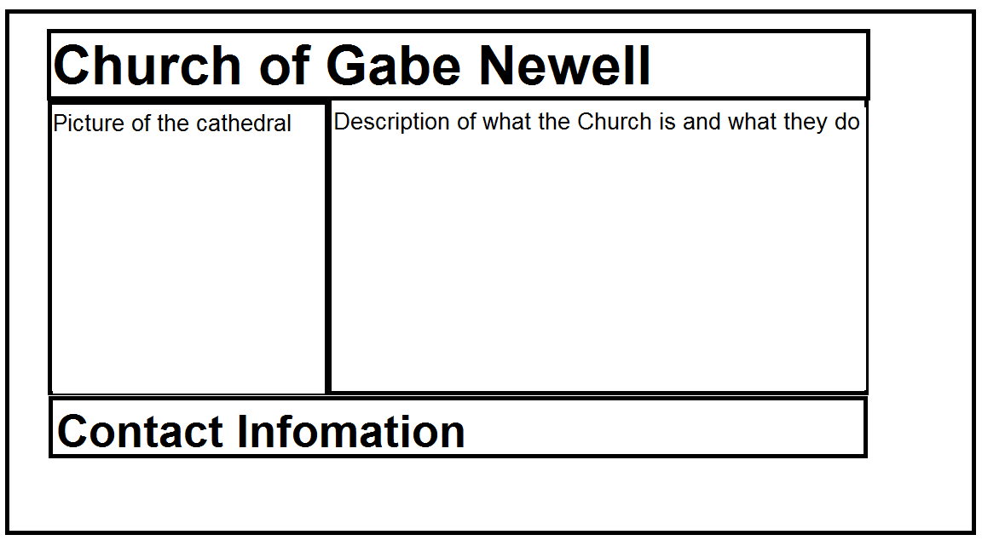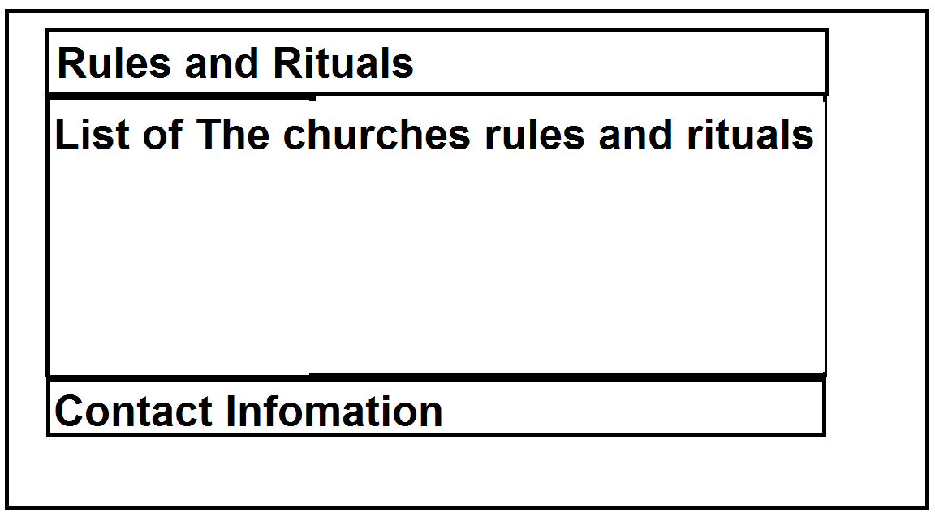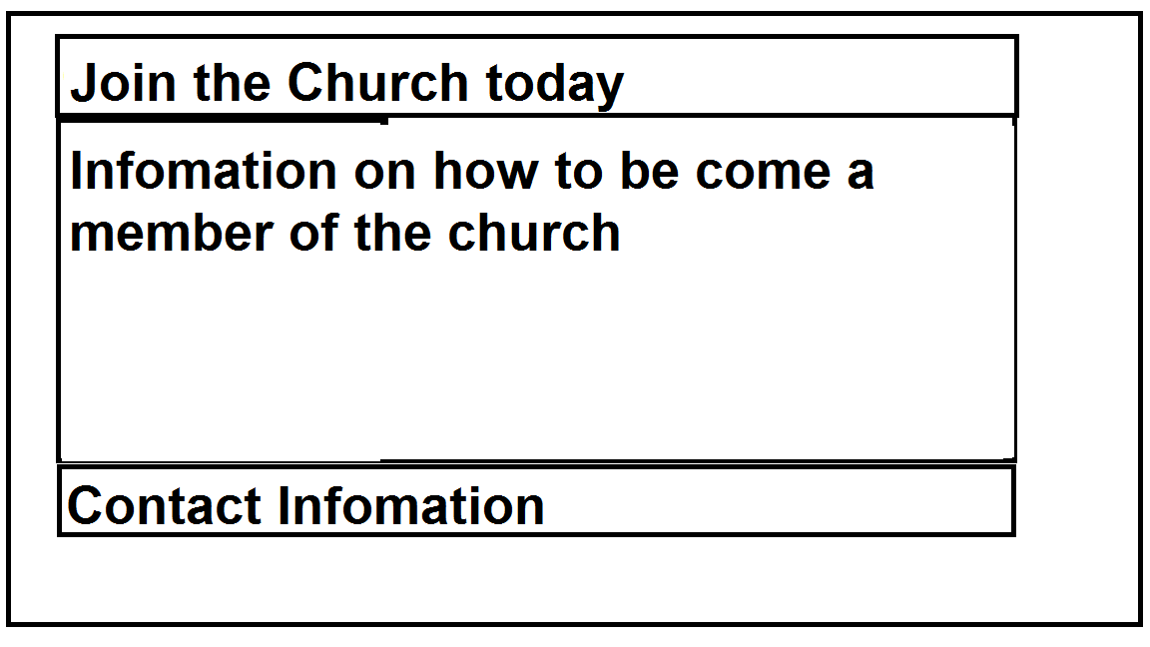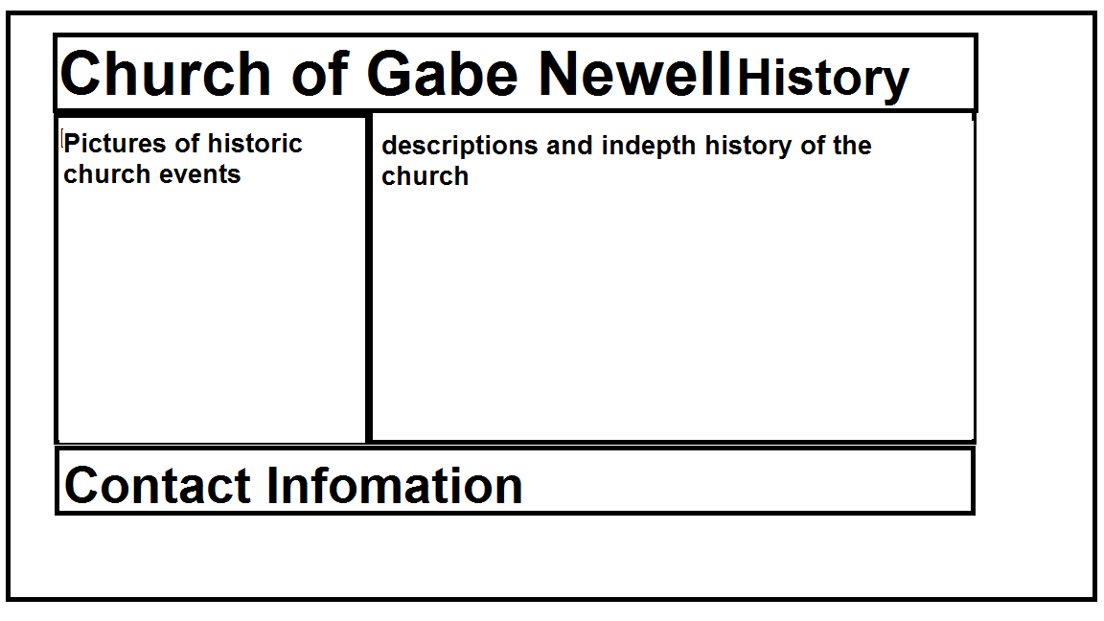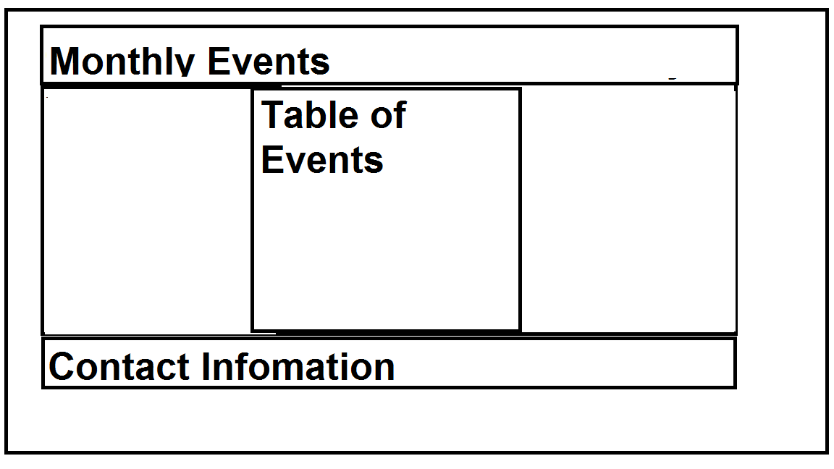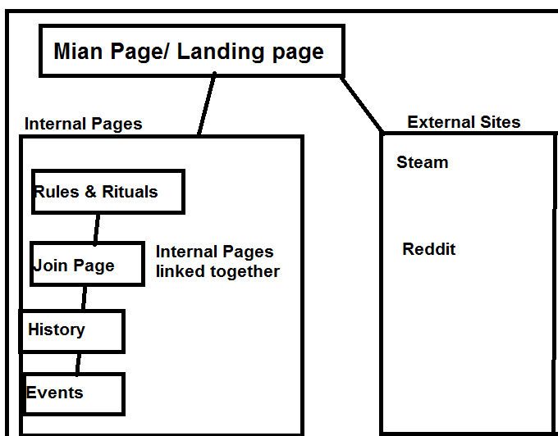

**The images used in the Website:**

* Church Building
* Gabe Newell
* Steam
* Shrines (Computers)

**Community Events**

* Church Service Time Table
* Monthly Events list

**Media**

The Priest would like there to be an informative video in the history section of the church making the accessibility to information much easier.

**Joining**

There will be a page with a link on every page of the website for users to enquire about joining the membership of the church.

**Budget**

Hourly rate of $17 for an estimated 20 hours of work coming to a total of $340 for labour.

There would be need for a server to host the website. Web hosting is estimated at costing $8 per month (https://au.godaddy.com, 2015). The web server doesn’t need to be high end as there would be few visitors and users. The Client might be interested in purchasing a server of their own instead of leasing a web server which could cost around $2000. The server would like to be up for 5 years at the very least, costing $480.

Having a buffer for your budget would be nice to ensure that any future unforseen costs can be covered and don’t have to be worried about and if they aren’t used they can be returned to the customer.

**Total budget:**

* Labour $340
* Server $480
* Buffer $246

**Coming to a total of: $1,066**

**Timeline**

|  |  |  |
| --- | --- | --- |
| **Goals** | **Date** | **Person Responsible** |
| Website Layout | 17th of April 2015 | Damien Robinson |
| Site Draft | 1st of May 2015 | Damien Robinson |
| Client Feedback | 8th of May 2015 | Peter File |
| Work on fixing website to client feedback | 15th of May | Damien Robinson |
| See client to show their feedback added to the website | 22nd of May 2015 | Peter File |
| Get the ok from the client | 27th of May 2015 | Peter File |
| Launch the Site live | 27th of May 2015 | Damien Robinson |

**Client information**

The Customer, Peter File is the priest of the Hatton vale church at the cathedrals phone number is 554 666 666.

Peter File

Church of Gabe Newell

3 Niemeyer Road

Hatton Vale QLD 4341

(07) 554 666 666

**References**

https://au.godaddy.com,. (2015). *Web Hosting from GoDaddy | Always Up. Always Fast.*. Retrieved 17 April 2015, from <https://au.godaddy.com/hosting/web-hosting.aspx>

Apostolic Church of Queensland,. (2015). *Apostolic Church of Queensland*. Retrieved 17 April 2015, from <https://www.google.com.au/maps/place/Apostolic+Church+of+Queensland/@-27.5626889,152.4543051,18z/data=!4m2!3m1!1s0x0000000000000000:0xfefacf9de59cd8b4>